Klumme (på engelsk): Why Europe is replacing its population: The Cascade Replacement hypothesis
1. december 2019 Helmuth Nyborg Klummer

Klummer på 24NYT er udelukkende udtryk for skribentens mening.
24NYT er ikke nødvendigvis enig med skribenten.

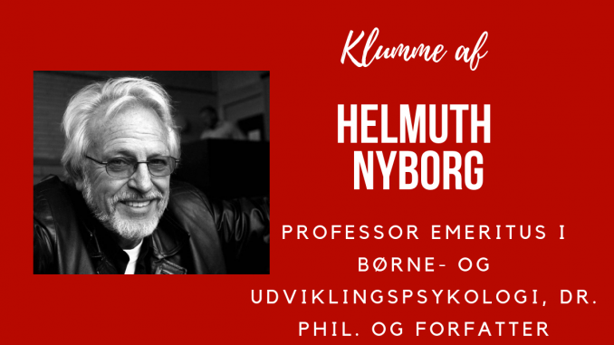
Recent demographic trends confirm that European populations are in the process of slowly being replaced by southern non-Western migrants. This is partly due to the significant migration since the 1960s and partly caused by the below-replacement fertility of high-IQ natives and the above-replacement fertility of some low-IQ migrant groups, in particular, those from Islam-dominated countries.
I, and many with me, have long time ago warned about this threat to the open societies of Europe, combined with the associated lowering of national intelligence averages, but to little avail.
It is in fact historically unique that a geo-socio-economic -structure like Europe self-supports the replacement of its democratic citizens with people growing up in political systems notoriously critical of – or unable to adhere to – democratic values, without first asking the European peoples themselves.
How on earth could this devastating development materialize?
Allow me to develop a hypothesis to explain this incredible demographic transition.
The ideal Humboldtian University is manned by bright people devoted to seeking the truth without restrictions and to follow it wherever it takes them. This ideal no longer applies to modern universities. Since the 1960s, most universities are increasingly subjugated by left-oriented scientists and administrators, who not only endorse ideas of equality, but also feel obliged to silence or virtually destroy colleagues who alternatively study the origin and consequences of individual, sex, and race difference ascribable partly or in toto to genetic differences. Such left-oriented universities constitute the first irresponsible element in a causal cascade, according to the Cascade Replacement Hypothesis.
The next elements in the chain are the journalists, the media, and some professional organizations. They likewise are increasingly dominated by left-oriented ideologies. They willingly re-distribute the Blank Slate misinformation about human nature flowing from the universities.
The third element is the politicians who silently accept cultural-Marxist ideas of equality and uncritically translate them into ineffective and sometimes fraudulent educational and counterproductive migration policy.
The fourth element in the chain is the European peoples, who themselves no longer question the equality illusion, as most responsible academics did in the early part of the 19.th century. A large majority of European peoples now uncritically support political parties open to migration of unequal fertile low-IQ peoples, many of whom reject European cultural values and prefer a Clan or Sharia inspired social organization. About 70% of the Muslim immigrants to Europe thus admit they would like Sharia laws to take over. Long-Term sub-replacement fertility of Europeans and above replacement fertility of southern non-Western immigrants will inevitably replace Europeans, enforced by a religious determination and war-like ideology that long ago have deserted well-fed Europeans.
The final element in the Cascade Replacement Hypothesis is powerful agents like the European Union and the United Nations. Neither are under direct democratic control and the latter is increasingly lobbied by numerous decidedly undemocratic nations. Both organizations institutionalize programs to further facilitate southern non-Western migration into Europe and to improve the conditions for those already living there.
Worst of all, not only the left-leaning universities but also the European Union and the United Nations are developing programs (e.g. the Marrakesh treaty) to punish those who disagree with their undemocratic demographic transition of Europe.
An event taking place 2. November 2019 in Oslo, Norway, illustrates the latter point.
It was a meeting for about 100 participants from all over the world, supporting democracy and rejecting violence. For some unknown reason, this private meeting by invitation also came to the attention of militant Antifa members. They met up in numbers, cut the electrical power to the meeting room, and tried to block the entrance. Heavily armed police then had to physically retain them, arrest them, and driving them away in several large police vans.
My talk at the meeting focused on aspects of the above-mentioned Cascade Replacement Hypothesis. In the name of transparency, I requested that a video copy of the talk was put on YouTube for public inspection, but it was immediately censured away by YouTube.
Instead, you can watch it on: http://helmuthnyborg.dk/?p=550
I will leave to you to judge whether we Europeans have arrived at a time in history, where we have already passed the point-of-no-return in decaying into a self-premeditated ethnic suicide, not only supported but reinforced by the European Union, The United Nations, unprincipled universities, left-leaning media, and the self-serving politicians.
If you (also) come to that conclusion, I ask of you to think about what to do now to save European civilization from Cascade Replacement by unequals.

